Scholingsweekend met TivoliVredenburg, 30.09 t/m 02.10
Akoesticum, Ede

Het weekend richt zich op vele facetten van Creative Music Making.
Centraal in het weekend staan:
- leiderschapsvaardigheden, zowel vanuit artistiek oogpunt als vanuit groeps- en individueel oogpunt
- creatieve compositie
- improvisatie
- artistieke betekenis en doelen
- sociaal bewustzijn en sociale impact

Voor muziekdocenten die voor het eerst meegaan valt er rondom deze aandachtspunten enorm veel te leren over de manier van werken, de opbrengst voor de leerlingen, de eigen muzikale ontwikkeling, en een forse uitbreiding van kennis en vaardigheden die het hele schooljaar in de eigen onderwijspraktijk toepasbaar is.

De docenten die al tijdens het scholingsweekend in London met de manier van werken kennismaakten krijgen ditmaal een veel groter accent op leiderschap en op artistieke ontwikkeling. Bovendien is dit een unieke gelegenheid om hun eigen toegenomen inzichten en aanpak te toetsen bij twee door de wol geverfde workshopleiders.

Voor alle deelnemers geldt als grote meerwaarde de kennismaking en vooral ook kennisdeling met collega’s van andere scholen, die ook intensief betrokken zijn bij de projecten van TivoliVredenburg.

Bio’s workshopleiders:

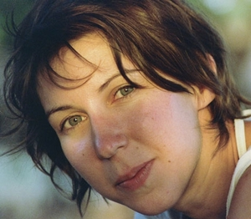
Detta Danford is a flute player, composer and workshop leader. She is co-founder of contemporary music ensemble Jetsam and has performed as part of the Bishopsgate Emerging Artists Programme and the Bath International Festival in addition to performances at the Barbican Centre, Shakespeare's Globe Theatre and the Wigmore Hall among others. In all areas of her practice, she is motivated by a fascination with and love of music making of all kinds, with artists, musicians and people from many different backgrounds and all walks of life. As a project leader, she has worked extensively with Barbican Guildhall Creative Learning, the London Philharmonic Orchestra, Aldeburgh Music, Yong Siew Toh Conservatory, Singapore and Tokyo College of Music amongst others. She is member of MAP/Making, a collective of musicians and visual artists who come together to collaborate and to create new work and since 2008 she has co-led Future Band, an ensemble dedicated to creative collaborative writing for young people aged 8-18. Detta graduated with honours from the Guildhall School of Music and Drama, where she now works with both the Masters in Music Leadership programme and undergraduate students.

Teaches at: Guildhall School of Music & Drama
Guy Wood has been highly active as a performer, composer and facilitator for over 15 years. Working for numerous bands, studio projects, theatre companies, TV and the advertising industry. He was educated in music from the age of 16 at The Leeds College of Music then studied Jazz at The Guildhall School of Music and Drama, London, with an exchange programme at The Prins Claus Conservatorium in Groningen, The Netherlands. He then completed his masters in Leadership at the GSMD in 2007.
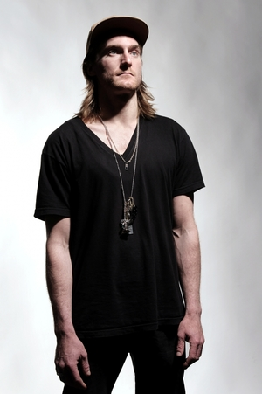
As a drummer he is working on various development projects with Jamie Telford (The Jam), I.R.O.K (Acid Bath records) and Stateless (Ninja Tune) amongst a session career that has recently seen him work on a project for Coca Cola. Over the last few years he has been busy as a producer and as one half of WW Music (www.wwmusic.co.uk), a music label and production agency that he runs with his long time collaborator Jo Wills. Their projects have ranged from artist development with vocalists such as Onallee (Roni Size Reprazent) and Tom Hickox to full length contemporary dance scores for The Tom Dale Company. Together they have also worked on composition and arranging jobs for the BBC, ECKO Unltd, Honda, Toyota, Sobrani, Nationwide and many more.
Guy is currently busy working on his solo project, known as ‘Wampa’, which is released through WW Music.
As a facilitator, Guy tutors on the Leading & Guiding module, as part of the first ever Joint masters in music programme in New Audiences and Innovative Practise. an exciting new programme developed between five host institutions in Europe (a.o. Prins Claus Coservatorium and Koninklijk Conservatorium Den Haag).

Teaches at: Prins Claus Conservatorium

